**Computer.h testing**

NOTE: Board being used for testing was not the latest board used.

**Constructor**

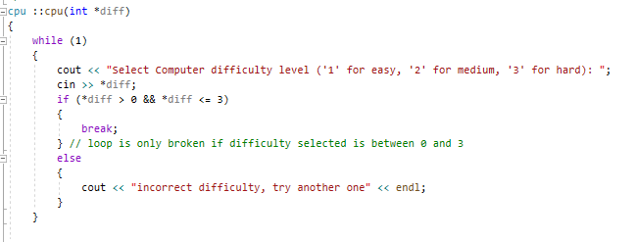

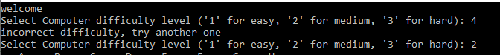

Showing validation for incorrect difficulty being selected and when a correct difficulty is selected it breaks the loop and continues into the program

**Computer’s go**

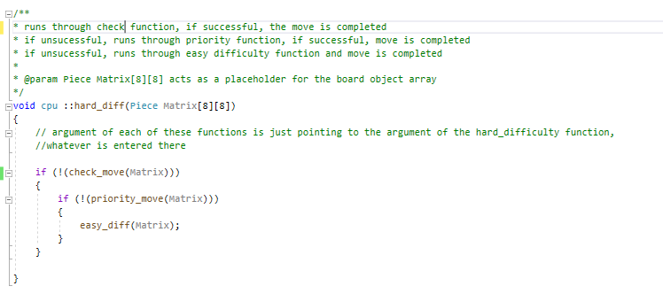

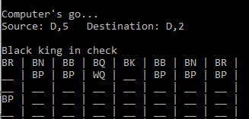

Computer makes a check move and to go is over

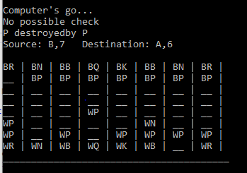

If there is no possible check, blackpiece/priority move function is called to take out a piece

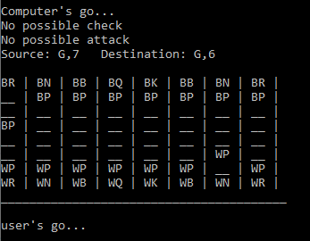

No check moves possible or possible attack, so it makes a random legal move.

**Priority move selection**

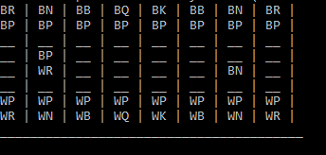

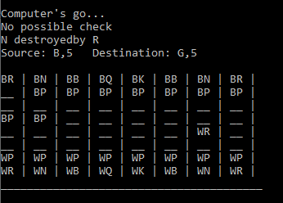

Chooses what piece to attack depending on its rank, in this case a knight is more valuable than a pawn.

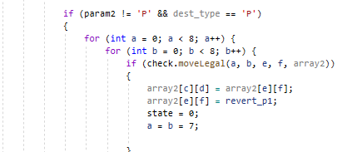

This part of the code acts as a defence mechanism to stop valuables pieces being lost just to attack a pawn.

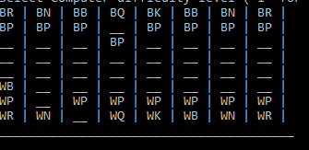

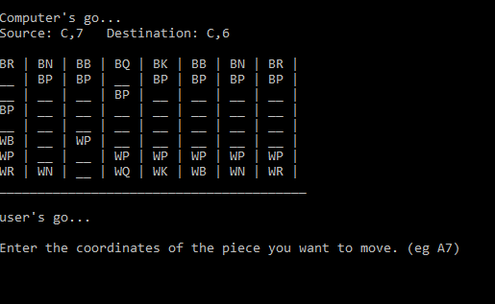

A random move is made instead of taking out the pawn and losing the bishop.

**Main terminal**

while loop with a state changer allows the terminal to run successfully and is only ended by checkmate.

